**[Your Company Name] Usage Report**

**(Please remember to delete the instructions and sample screenshots after you have input your actual screenshots)**

To retrieve this screenshot, please login to your eCommerce website backend.

Go to Shop and you will see this.

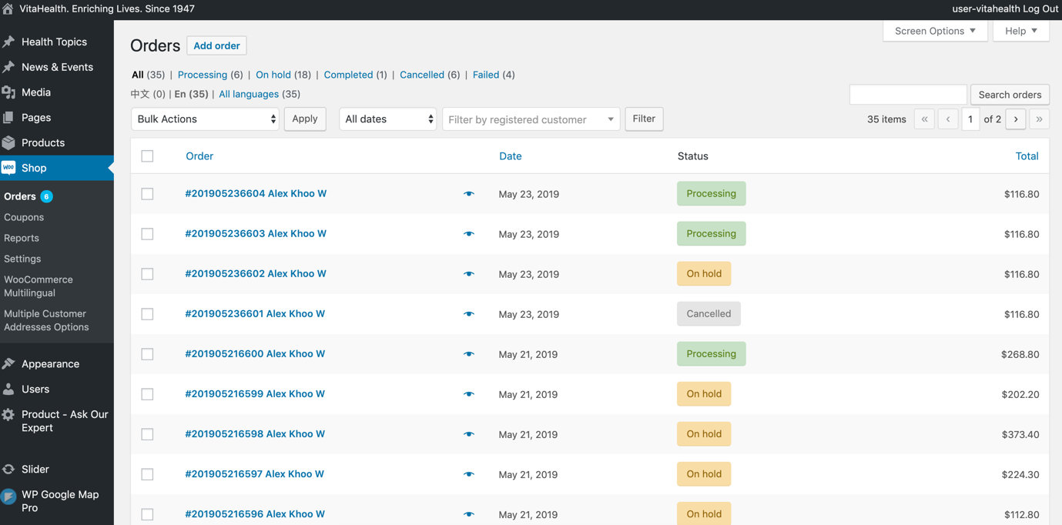

To get this screenshot, please click on any order and you will see something like this. Please screenshot the whole order details.

To get this screenshot, please go to Shop > Reports > Orders > Year

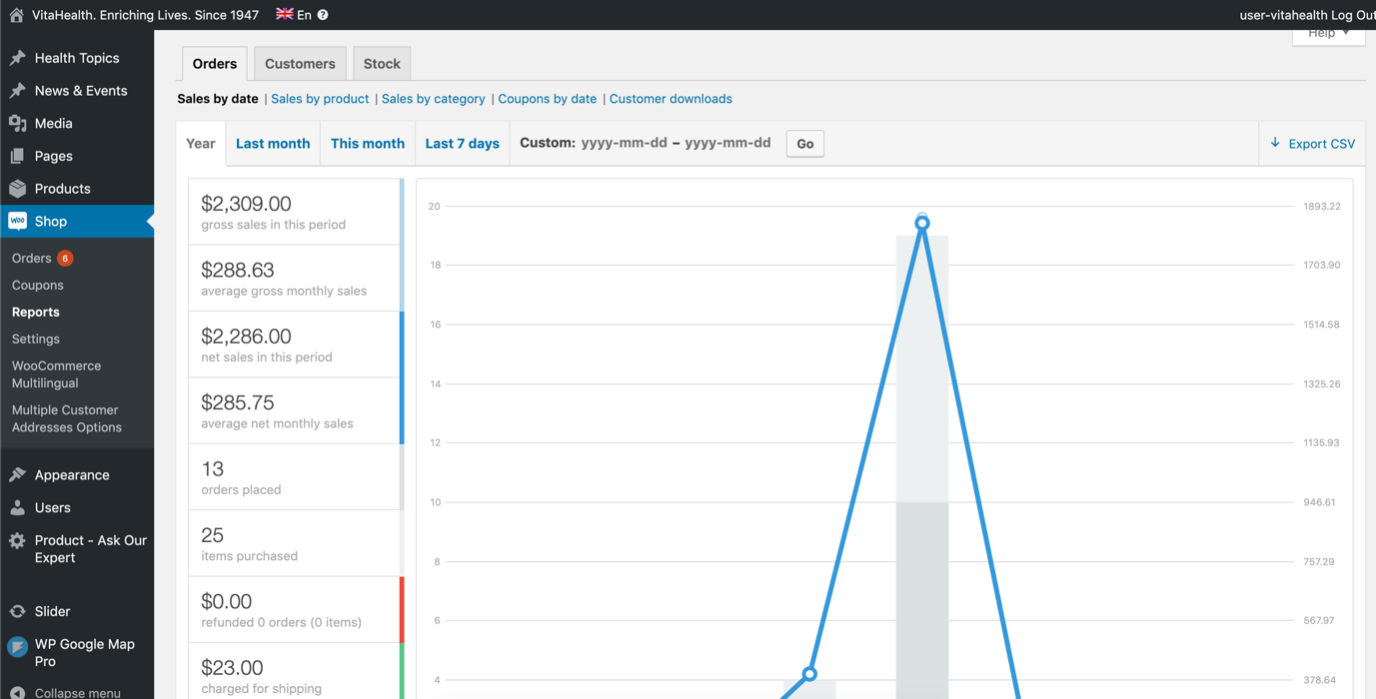

To get this screenshot, please go to Shop > Reports > Customers > Year

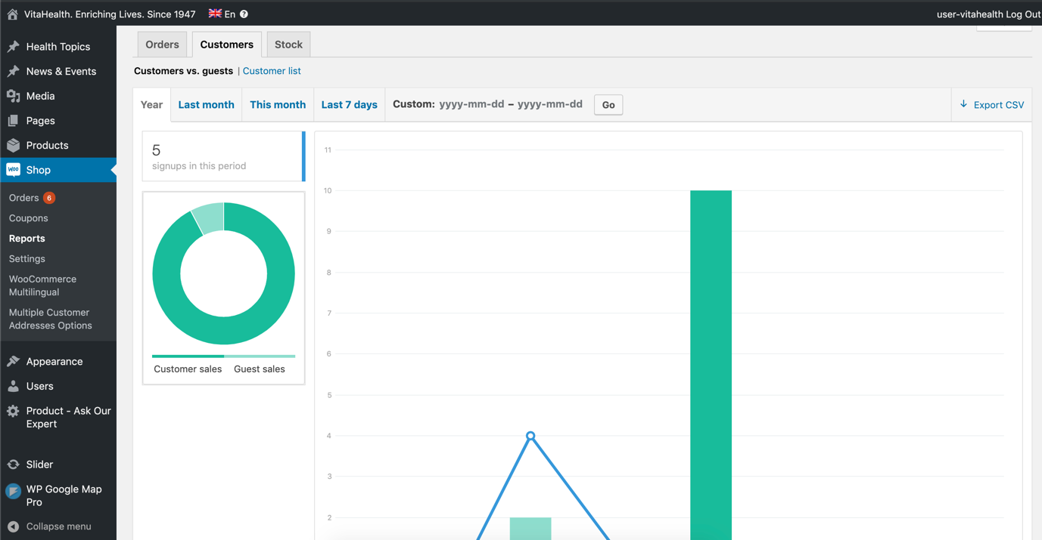

To get this screenshot, please go to Shop > Reports > Stock

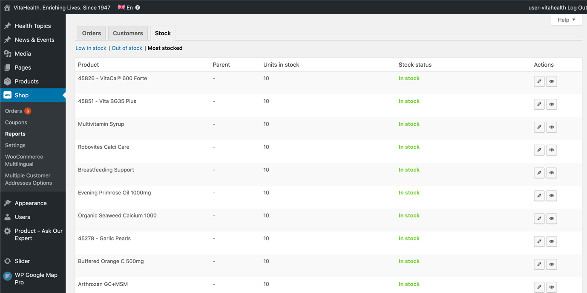

To get this screenshot, please go to Shop > Analytics > Revenue

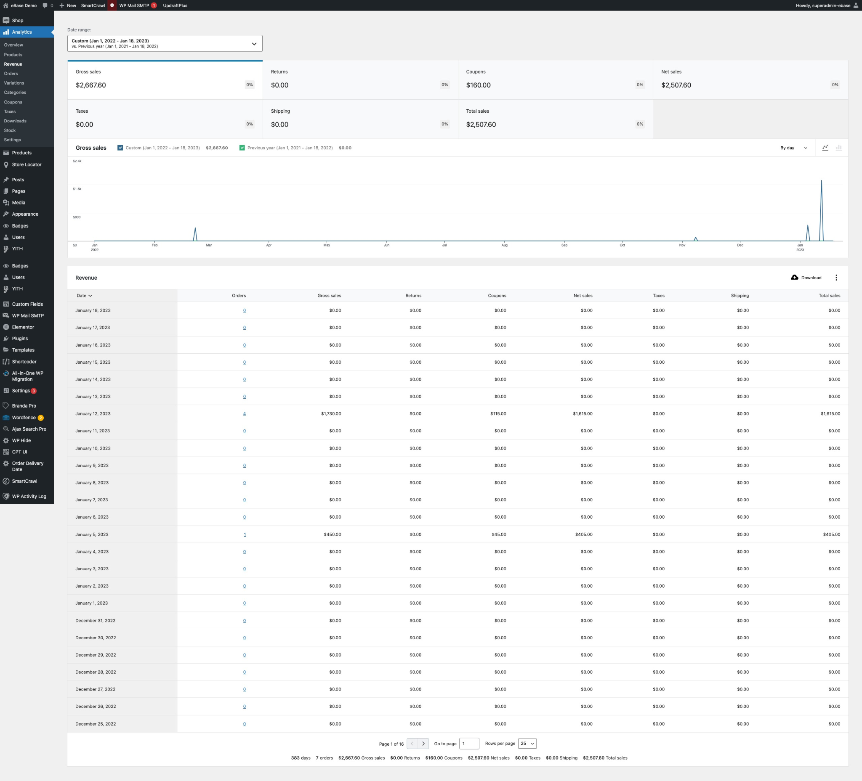

To get this screenshot, please go to Shop > Analytics > Orders

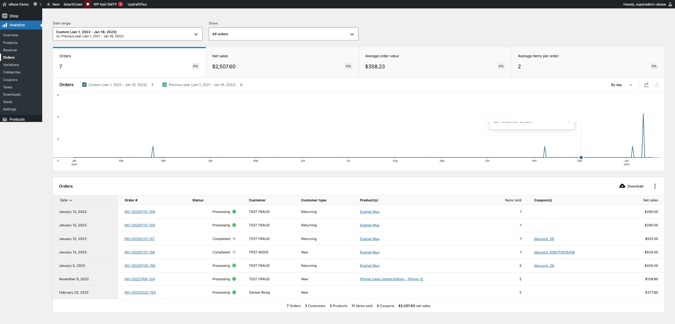

To get this screenshot, go to your online store to snap your [Shop] page.

To get this screenshot, go to your checkout page to snap the online payment gateway.

